Decision making: Modelling procedures
Detail design
Marcel W.
Project:
Pokemon card case
To develop a clear procedure and methodological structure for 2D and 3D CAD modelling.
[NOT FOR SUBMISSION]
Table of Contents
CHAPTER 1 INTRODUCTION 5
1.1. Background 5
1.2. Structure 5
CHAPTER 2 OVERVIEW 7
2.1. CAD 7
2.2. Product model 9
CHAPTER 3 METHODOLOGY 11
3.1. Modelling management 11
CHAPTER 4 PROCEDURE 14
4.1. Introduction 14
4.2. Prerequisites 14
4.3. Top-Down design 15
4.4. Bottom-Up design 15
Bibliography 16

Table of Figures
Figure 1: Final product methodology overview 9
Figure 2: Root folder structure 12
Index of Tables

INTRODUCTION
The procedures and structure for modelling which must be followed are fundamentally based on the general project specification. This takes into consideration all the important elements which must be involved within the process. Of course, along side this, a valid and logical format to the structure and procedure must be applied such that it is possible for the designer to implement.

Background
A procedure is an important statement which enables the execution of complex processes in a logical clear manner. In addition to that, procedures allow a clear understanding and a top-level analysis of the process before execution allowing further refinement and ability to modify such process so it is easier to execute.

Structure

INTRODUCTION
This first chapter aims to describe the premise of this whole document. It is important to state the general prerequisites before delving within the more specific matters.

OVERVIEW
The overview chapter is a chapter which aims to detail the prerequisite process of procedure writing. As such, detail in terms of required elements and tools that will be used within the procedures will be mentioned.

METHODOLOGY
This is a chapter concerned with describing the method and environment where the modelling efforts will be concentrated.

PROCEDURE
This is the main chapter detailing the modelling procedures.

OVERVIEW
The general overview of the procedure involves the conceptual understanding of the underlying structure and ability to make good engineering judgement. Two major elements are highlighted for the procedure: CAD and the product itself.

CAD
The set-up involving CAD will mainly aim to comply with the specification and general engineering design methodology. A thorough foundation must be present for the identification of relevant elements which will be used for the accomplishment of aims.

Types
Firstly, the types of CAD which identify the dimensionality scope. Both types will be used, 3D will be the main type while the 2D will be a secondary type which will be dynamically derived from the 3D model.

2D
This type will be derived from the created 3D designs within the same CAD package. It is not required to use CAD packages which are dedicated for 2D designing.

3D
This type will be fundamentally created using computer modelling methodologies within CAD based software. Practically every 3D enabled CAD package also has a 2D workbench allowing quick 2D drafting within the same software.

Modelling techniques
In terms of modelling techniques, two important techniques in the scope of this project would be focused: Parametric and assembly.

Parametric
Technique which utilises parameters to drive the modelled item using features, equations and constraints. This allows for the designer to capture design intent, allowing quick changes, intelligent design and logical control.

Assembly
A technique within CAD which handles multiple separate 3D CAD files to represent them within a singular unified product. Every file which is included within the assembly must be positioned using either an absolute coordinate placement or by using mating conditions. Such files can either be singular parts modelled using parametric or non parametric means or assemblies which are treated as sub-assemblies under the context of this assembly.
Within this project, sub-assemblies shall not be used.

Representations
Only 2 representations shall be used for this project: B-rep and CSG.
According to the specification, it is required to prefer the CSG representation whenever possible – only use B-rep when necessary. In the case of Open SCAD, the pure CSG representation will suffice (this model shall be treated as proof of concept, and shall not progress past CAD).

Constructive Solid Geometry (CSG)
This is the preferred representation for this project.
CSG is a basic representation which fundamentally relies on the concept of primitives. Each primitive is a solid object. The operation of boolean tools is used within this representation, such operation allows two primitives to essentially construct complex solid geometry.
Unfortunately, this representation comes with severe limitations and as such may need refinement within other representations, such as B-rep.

Boundary Representation (B-rep)
This is the secondary representation for this project.
The B-rep is a newer representation than CSG. It fundamentally relies on the concept of boundaries which is a 2D surface that defines the 3D objects volume. As such, a B-rep solid is fundamentally different than a CSG solid.
It is the most common representation used today, this is due to the efficiency, parametric characteristics, variety of specific tools, and the ability to work with surfaces.

Product model
Utilising the noted capabilities of CAD is only possible when the concept for creation is understood correctly and is physically sound. As such, the identification of each part, sub-assembly and mechanism of the assembly must be done.
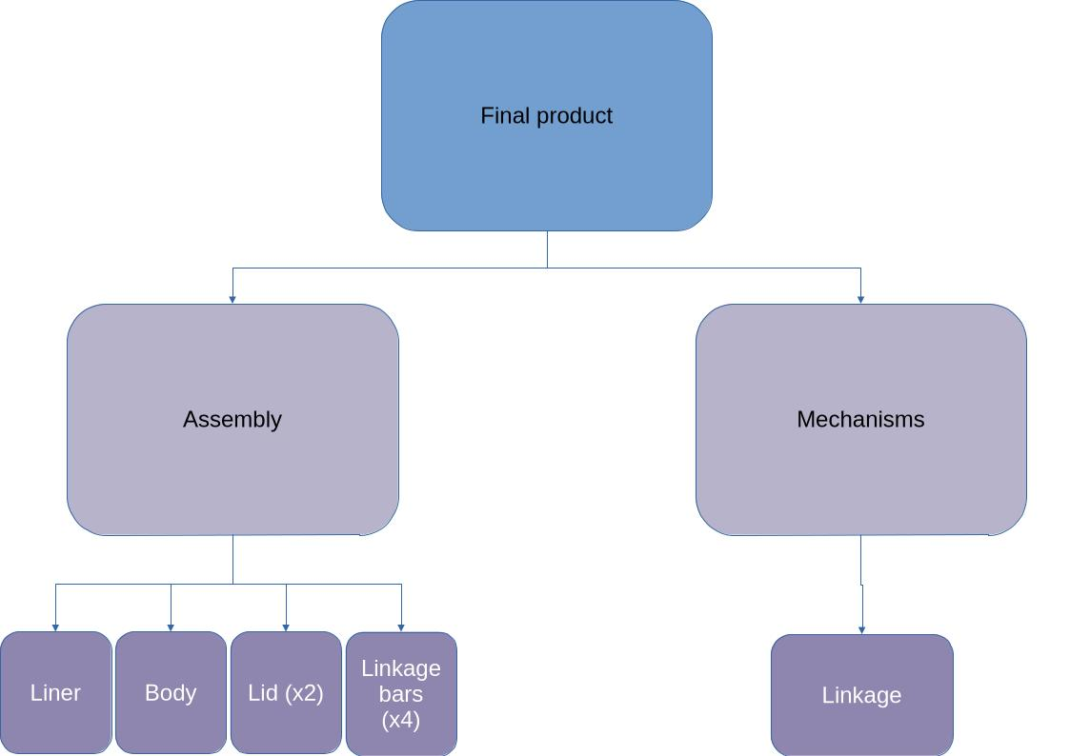Figure 1: Final product methodology overview

Assembly
The product will not use sub-assemblies; only singular parts:
- Liner
- Body
- Lid (x2)
- Linkage bars (x4)

Mechanisms
The only dynamic mechanism which will be used corresponds to the linkage bars. This linkage will be the primary way the lids will operate – revolving around the body part.

METHODOLOGY

Modelling management
The modelling efforts within the management scope must be logical and organised. As such proper file names and file hierarchy must apply.

File structure
The modelling file structure will start within the project provisioned “2. modelling” directory – this will be treated as the root. Within this root directory, two main directories will be present: Design, used for storing model files; and Data, used for storing data that is supplementary to the models.

“Design”
Within this directory precisely 3 directories will be created corresponding to the 3 CAD packages in use (specified within PDS). Such directories will propagate into 2 more directories indicating the 2 approaches: bottom-up and top-down; which are required per CAD package. Within each approach directory is where the local files live, this is where the model will take shape.
It is important that despite this arrangement, each approach despite the CAD package is its own sub-project within this whole project – they are individual efforts.

“Data”
Within this directory, multiple folders will be placed in respect to the supplementary scope. The major scopes within this directory are: the design table and the file index.

Representation
A clear representation of this structure can be seen below.
Figure 2: Root folder structure

*: These two directories will be located in the SolidWorks and the FreeCAD directories excluding OpenSCAD.

File ID system
With an adequate file system, the management of model files becomes much easier. However, referencing specific model files still persists as a problem. That’s why a file ID system is necessary to centrally allocate each model file a specific ID to aid in management. To accomplish this, an adequate naming scheme must be first devised to name each file an easily identifiable number such that finding it in a database would be easy.
This system will operate from a central location which will be the index directory located within the data directory. File indexes for the purposes of this project will be stored on a division & scope specific, centralised, flat-file database (spreadsheet).
The file ID indexing format is as follows:
“<Prj ID>_<Div ID><Scope ID>_<File Cat><LocalID>”.
- Prj ID: Letter/s used as a shorthand for Identifying the whole project. “P” in this case is used.
- Div ID: Letter/s used as a shorthand for Identifying project divisions – within this project, differing CAD packages are divisions within this project. FreeCAD = “FC”; SolidWorks = “SW”; OpenSCAD = “OSC”.
- Scope ID: 1 digit ID specifying the given scope within a division. In this case it would be either top-down = “1” or bottom-up = “2”.
- File Cat: File category. Refers to the premise of a file being a part, assembly or a master. In the scope of this project, only parts = “P”; and assemblies = “A” will be used.
- Local ID: This is an 3 digit ID that starts from 0 and is local to the file category and the scope - such that other file categories and scopes have their own ID number bank.

Allocation
Example allocation for FreeCAD model files. Other packages will have a different sub-project ID:
Table 1: Example file ID format allocation
Part | Top-Down | Bottom-Up
Liner | P_FC1_P001 | P_FC2_P001
Body | P_FC1_P002 | P_FC2_P002
Lid | P_FC1_P003 | P_FC2_P003
Linkage bars | P_FC1_P004 | P_FC2_P004
Final assembly | P_FC1_A000 | P_FC2_A000

Database
Like stated, the database will be flat-file provided through a spreadsheet. For the purposes of this project only LibreOffice Calc is permitted and used.
Within the top level overview, the index directory will include many spreadsheets which correspond to the division and scope. This allows for a standard representation of elements within the database file.
The standard representation is the allocation of resources in terms of the category in different sheets. This is an important feature as it provides a database-like interface allowing records to be stored according to their category. Furthermore, management becomes much more efficient and effective.

Design tables
Design tables are useful utilities for managing variables/equations and configurations. Within this project design tables will only be used for variables/equations. Similar to the file ID system, design tables will work as an extension specifically focusing on intra part elements.
Discrete geometric entities will be indexed within an ID system specific to design tables. This will allow for more precise geometric dimensioning as well as geometric placement. Equations will be secondary to this, allowing a centralised location for complex statements; equations will enable dynamism and a greater design intent.

PROCEDURE

Introduction

Prerequisites

File ID system
The file ID system must be adequately deployed before modelling can commence. The method of deployment is found within the methodology chapter – it essentially involves the creation of a centralised database.

Design tables
Design tables are necessary to the modelling. Its function is to provide the geometric properties in a centralised file allowing quick and efficient implementation.

Top-Down design
This is the first stage. Within the project this is identified as a “scope” since the project first needs to be completed in a parametric easy to change top-down design before producing a more concrete assembly in bottom-up.

Bottom-Up design
This is the second stage of the modelling cycle, the final top-down model must be redesigned in a bottom-up fashion as to prepare the assembly for fabrication. This is a more concrete method allowing for a more precise inspection and verification before the manufacturing stage. Each division (except OSC) essentially has the task to produce a single model – scopes serve as a logical development tactic.

Part modelling

Assembly modelling
Bibliography
- Linkage types: https://www.firgelliauto.com/blogs/news/different-type-of-linkages
- Link rod failure: https://pmmonline.co.uk/technical/link-rods-their-purpose-and-why-they-fail/

